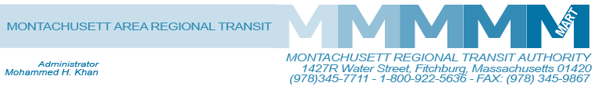

Posted 01/15/2014 at 1:53 pm by JAV

EMERGENCY
MEETING OF THE MART ADVISORY BOARD
MART Maintenance Facility
1427R Water Street
Fitchburg, MA 01420

Friday January 17, 2014
2:00 P.M.

Agenda

- Call to Order
- Administrative Matters
A. MART Update on GIC and State Retirement Benefit Implementation and Associated Issues

III. Adjournment
C: City and Town Clerks: Please post this notice pursuant to MA General Laws Chapter 30A,
Sections 18-25.

